# Scenario 1: View Organizational Requirements

## Scenario Description

* View upcoming requirements needed for the organization based on a requested date

## Version Control

|  |  |  |  |
| --- | --- | --- | --- |
| Version # | Date | Author | Description |
| 1.0 | 25/08/2019 | Aaron Brody | Initial Version |

## Test Scripts

The following scripts will cover this scenario:

* 1.1 Default organizational requirements view
* 1.2 Custom scoping and viewing requirements
* 1.3 Resource is able to be allocated through this view

## Use Case

* View Organizational requirements

## Test Components/Requirements

This test scenario covers the following high-level test requirements (see scripts below for specific requirements covered by each test script):

* Any project containing an unassigned resource for the selected period will be displayed.
* Allow the company to view unfulfilled requirements easily

## User Groups

* Project Manager
* Resource

## Script 1.1: Default organizational requirements view

### Script Description

* A Project Manager is able to identify which project requirements have not been fulfilled and allocate a resource if required.

### Testing Requirements

This test script covers the following specific testing requirements:

* The default view contains projects with requirements that are not fulfilled only for the next month.

### Setup

* A project named “Next month” must exist with an unfulfilled requirement during the next month 15/06 to 15/07

### Teardown

* Delete the “Next Month” project

### Script Steps

| **Step #** | **Test Action** | **Expected Results** | **Pass/ Fail** |
| --- | --- | --- | --- |
| 1 | Click “View Projects” Button on the navigation bar | Opens View Projects Page, loads containing the Next Month project | PASS |
| 2 | Take screenshot and add results below test execution area |  |  |

### Test Execution

|  |  |  |  |  |
| --- | --- | --- | --- | --- |
| Date/Time | Tester | Test ID | Test Phase | Status |
| 08/09/2019 | Brodie Osborn | #1 | IOCM | Test Completed |

Add screenshot here:

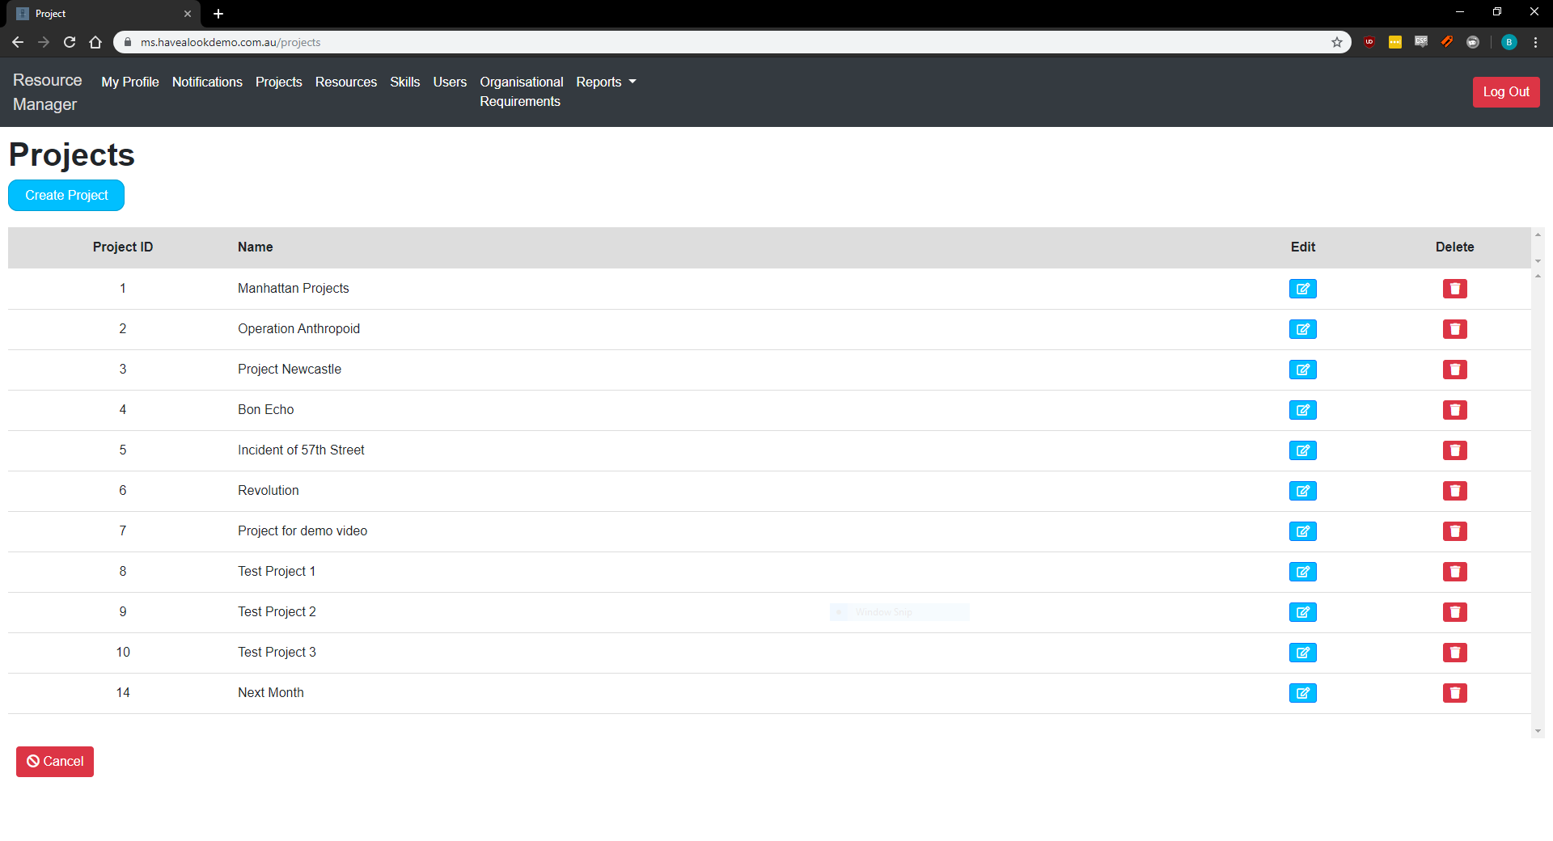

## Script 1.2: Custom scoping and viewing requirements

### Script Description

* A Project Manager is able to alter the search requirements and see the requirements for a specified period

### Testing Requirements

This test script covers the following specific testing requirements:

* Allow a project manager to see the types of resources that will be needed for a specified time period

### Setup

* “test project Extended Timeframe” must be created with a resource requirement between 01/Nov/2021 and 30/Nov/2021

### Teardown

* N/A

### Script Steps

| **Step #** | **Test Action** | **Expected Results** | **Pass/ Fail** |
| --- | --- | --- | --- |
| 1 | Click “View Projects” Button on the navigation bar | Opens View Projects Page, loads containing the Next Month project | PASS |
| 2 | Updates Start and end date dialogue to encompass 1/Nov/2021 to 30/Nov/2021, then click the View Requirements button | The results should update to include the “Test Project Extended Timeframe” project | PASS |
| 3 | Take screenshot and add results below test execution area | Screenshot exists |  |

### Test Execution

|  |  |  |  |  |
| --- | --- | --- | --- | --- |
| Date/Time | Tester | Test ID | Test Phase | Status |
| 08/09/2019 | Brodie Osborn | #1 | IOCM | Test Completed |

Add screenshot here:

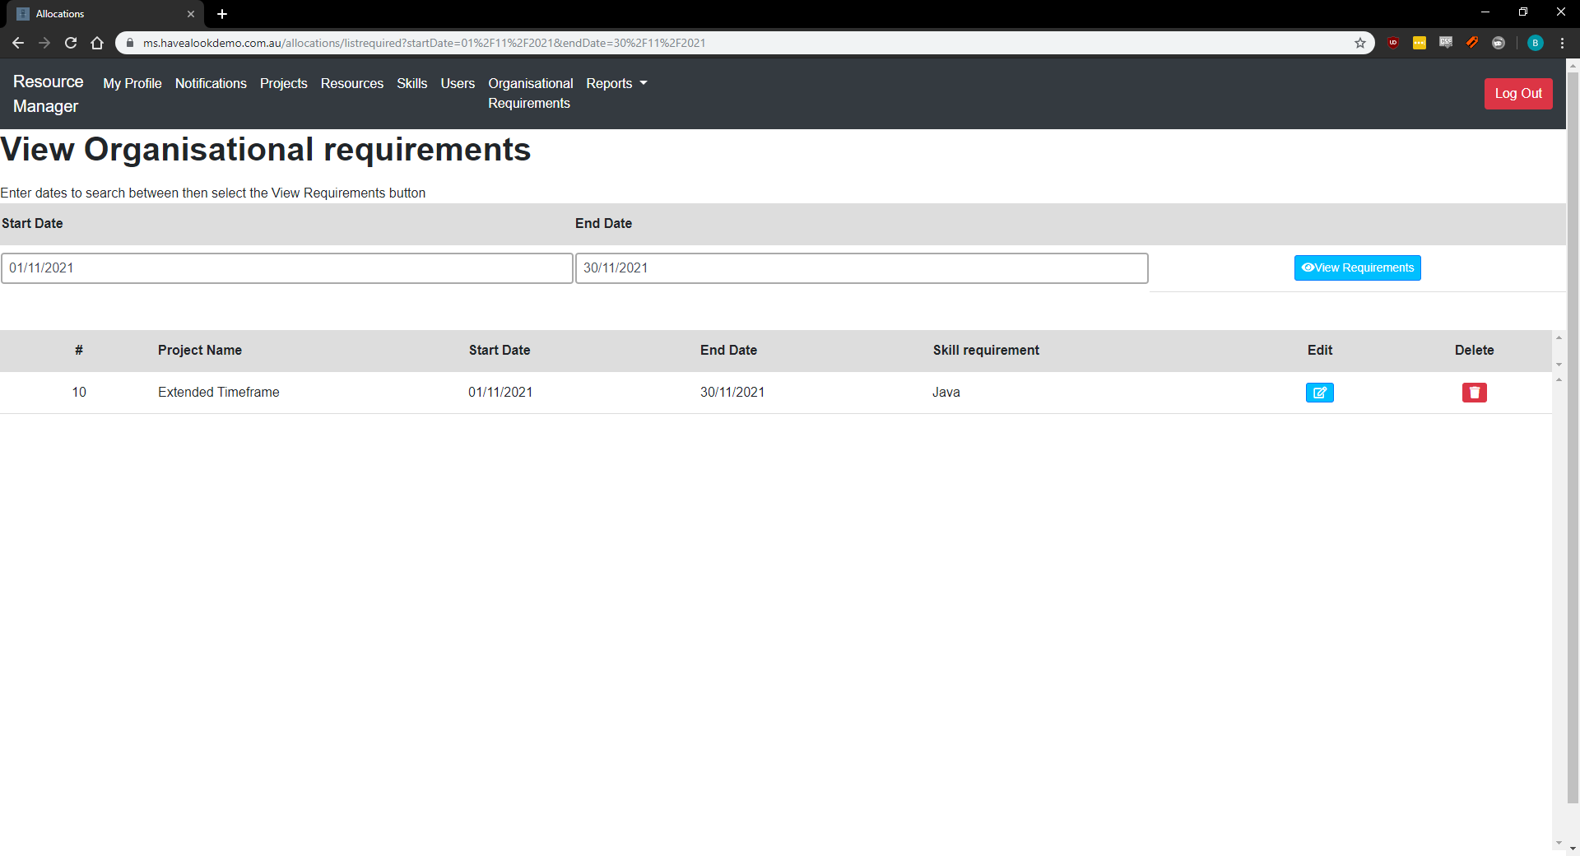

## Script 1.3: No Resource available during the timeframe specified

### Script Description

* A Project Manager is able to locate a resource for the skill requirement as required

### Testing Requirements

This test script covers the following specific testing requirements:

* Ensure that resources can be located to meet a skill requirement from the view organizational requirements page

### Setup

* “test project Extended Timeframe” must be created with a resource requirement in Java between 01/Nov/2021 and 30/Nov/2021 for 20 hours
* “Test Resource Java” should be created with Java and at least 20 hours available and have no allocation for November 2021

### Teardown

* N/A

### Script Steps

| **Step #** | **Test Action** | **Expected Results** | **Pass/ Fail** |
| --- | --- | --- | --- |
| 1 | Click “View Projects” Button on the navigation bar | Opens View Projects Page, loads containing the Next Month project | PASS |
| 2 | Updates Start and end date dialogue to encompass 1/Nov/2021 to 30/Nov/2021, then click the search button | The results should update to include the “Test Project Extended Timeframe” project | PASS |
| 3 | Click the Allocate Icon on the skill requirement | Open the Resource Search window  Test Resource Java Should be selectable | PASS |
| 4 | Check the test Resource Java resource then select “ok” | Test Resource Java is saved to skill requirement | FAIL |
| 5 | Take screenshot and add results below test execution area | Screenshot exists |  |

NOTE: When allocating the resource to the requirement in step 4, the allocation was instead immediately deleted as in the screenshot below. Did not occur in other tests which required the same actions (allocation of resources).

### Test Execution

|  |  |  |  |  |
| --- | --- | --- | --- | --- |
| Date/Time | Tester | Test ID | Test Phase | Status |
| 08/09/2019 | Brodie Osborn | #1 | IOCM | Test Completed |

Add screenshot here:

